Slicing File
Write a program that takes any file and slices it to n parts. Write the following methods:
Slice(string sourceFile, string destinationDirectory, int parts) - slices the given source file into n parts and saves them in destinationDirectory.
Source File | Destination Directory
parts = 5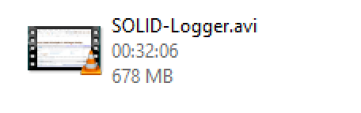 | 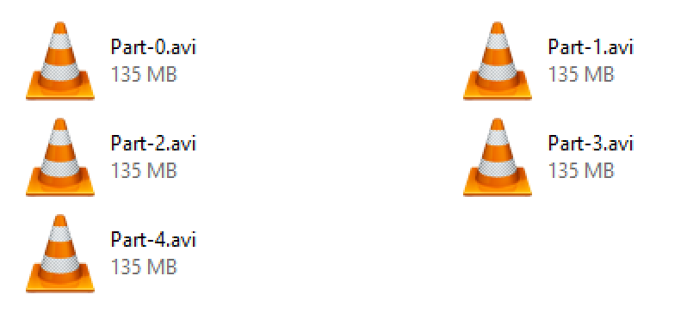

Assemble(List<string> files, string destinationDirectory) - combines all files into one, in the order they are passed, and saves the result in destinationDirectory.
Source Files | Destination Directory
 | 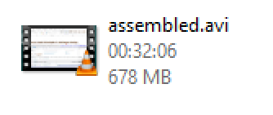

Use FileStreams. You are not allowed to use the File class or similar helper classes.

